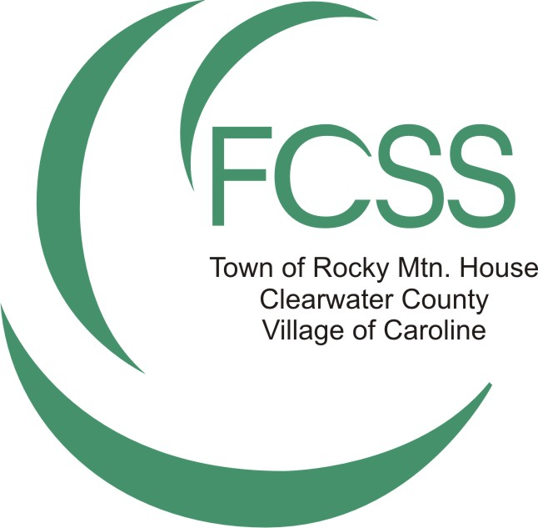
2025 Community Grant Application
Clearwater Regional FCSS

Submission Deadline:

The 1st of every month excluding July and August – please submit before or after because there are no board meetings

DROP-OFF: Clearwater Regional FCSS Office MAIL: Clearwater Regional FCSS Office EMAIL: fcssmanager@rockymtnhouse.com
5110 50 Avenue PO Box 1509
Rocky Mountain House, AB Rocky Mountain House, AB PHONE: Andrea Hardy – (403) 847-5270 T4T 1B2

GRANT APPLICATION CHECKLIST

- Application is fully completed
- Detailed budget for the grant application indicating where FCSS dollars will be spent
- Organization’s Budget for the current year
- Most current audited financial statements
- List of current board members including name and position
- Application is signed
- It is not necessary to mail an application to the FCSS Office if the digital copy is signed
- A digital copy of the application has been emailed to the FCSS Manager: fcssmanager@rockymtnhouse.com

Total Non-FCSS Funding for Project: | 2025 FCSS Funding Requested: | Previous FCSS Funding:
Name: $:  Name: $:  Name: $:  Name: $:  Name: $:  Name: $:  Name: $: | $ | 2024:  2023:  2022:  2021:  Other:

1. WHAT IS YOUR 3-YEAR SUSTAINABILITY PLAN? FCSS FUNDING CANNOT BE GUARANTEED YEAR-TO-YEAR.
Start typing here - boxes will expand

2. CONTACT INFORMATION
Project Name
Organization Name
Mailing Address
Postal Code
Contact Person
Title
Phone Number
Email Address
Alternate Contact Person
Title
Phone Number
Email Address

3. TYPE OF ORGANIZATION
Alberta Societies Act Registration Number: | Government Agency:
Charitable Number (if applicable): | Other (please specify):

4. ORGANIZATION INFORMATION
Please provide a brief overview of your organization (i.e., Mission/Vision, mandate, history).
5. PROGRAM OVERVIEW
Program/Project Title:
Issue Identification:
What community issue, need or situation are you responding to?
For example: Youth are exhibiting some poor choices and risk behaviors, youth have been seen loitering & doing drugs.
Overall Goal:
What change or impact do you want to achieve?
For example: We want to see seniors that are connected and engaged and supported to thrive.
Broad Strategy:
How are you going to address the issue, need or situation? (What are the actions/steps/activities) i.e., Workshops, counselling, community forums etc.
For example: I’m going to provide a 12-week course on parenting that’s facilitated by a social worker.
Who is served:
Target Group
For example: Seniors living alone, community members, dads who are single parenting on a low income, etc.
Rationale:
Why will your plan help you to achieve your goals?
What evidence do you have that this strategy will work?
For example: If I run a 12-week parenting course, then parents will have better parenting strategies, leading to healthier functioning in the family. Or research shows that if…, then…
Relevant Statistics:
Please include relevant statistics from previously done programs or programs from successful communities.
For example: 1 in 5 people experience a mental health issue within their lifetime. Suicide is the second-most leading cause of death in adolescents.
Partners:
Who & what resources does each Partner bring to the program/project (i.e., Money, staff, knowledge etc.)

6. ARE THERE SIMILAR PROJECTS BEING OFFERED IN YOUR SERVICE AREA? IF YES, HOW DOES YOUR PROJECT DIFFER FROM EXISTING PROJECTS?

7. ANTICIPATED NUMBER OF ATTENDEES:
 | 8. OUTCOMES | ***Please contact the FCSS Office to complete this section***
 | Outcome Measured: | Indicator(s) of Success:  (How will you know this outcome has been achieved?) | Provincial Outcome & Indicator Alignment: | Measures  Bank  Measure  Number: | Measure(s):  Outcomes Measures Bank spreadsheets:  https://www.rockymtnhouse.com/p/fcss-family-community-support-services
 | EXAMPLE:  Improved Social Well-Being of Individuals | Participants report that they are better at getting through hard times because they believe in themselves. | Individual Outcome #1: Individuals experience personal well-being. Indicator – Resilience: the extent to which people can deal with life’s difficulties. | PM1 | As a result of (program name), I am better at getting through hard times because I believe in myself.

9. ADDITIONAL INFORMATION
Identify Measurement Tool(s) Used:
- Survey | - Observation | - Interview | - Focus Groups
When will you survey your attendees? | - Before and after (preferred) | - Just after
DECLARATION:
I declare that all information in this application is accurate and complete and that the application is made on behalf of the organization named on Page 3 with its full knowledge and consent and complies application criteria.

If any program or project funding remains, I will contact the FCSS Office immediately, so the funds may be redistributed before year-end.

The organization will fully spend funds by December 31, 2025 and submit a final report by January 31, 2026.

I acknowledge that should this application be approved, I/my organization will have entered into a funding agreement, which will outline the terms and conditions.

Print Name Authorized Signature Date
By Mail:  Clearwater Regional FCSS  Box 1509  Rocky Mountain House, AB  T4T 1B2 | Questions? Please contact:  Andrea Hardy at (403) 847-5270  email: fcssmanager@rockymtnhouse.com

